1.create script to list all files in /var/log every 5 seconds and append the list to /tmp/list.log file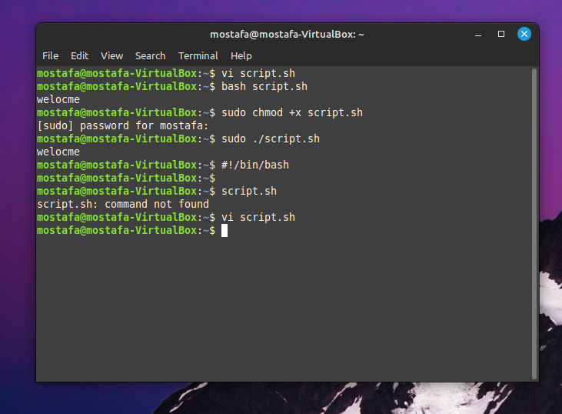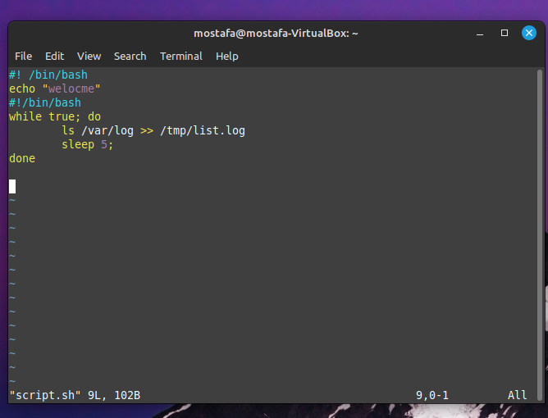

2. copy the script to /usr/local/bin directory and set the execution attribute to it



3. create systemd service file to execute the the script as background service

Sudo systemctl1 daemon-reload

Sudo service myServ start

Sudo service myServ status

4. using cron, schedule a job every 5 minutes to copy /tmp/list.log file to /tmp/list.log.1 and compress the file using zip command

